Mid-Semester Project Expectations
Course: Back-End Web Development
Level: Level
Assessment Type: Mid-Semester Project
Total Marks: 30
- Project Objective
Students are required to design and develop a simple dynamic web application that demonstrates integration of:
- Front-End technologies (HTML5 and CSS3)
- Back-End programming using PHP
- Form handling and session management
The project should reflect understanding of core concepts taught during the first half of the semester.
2. Project Requirements
A. Front-End Requirements (HTML & CSS)
Students must demonstrate:
- Proper use of HTML5 semantic elements (header, nav, section, footer)
- Well-structured and properly indented HTML pages
- External CSS styling
- Clear navigation between pages
- Clean and user-friendly interface
B. Back-End Requirements (PHP)
Students must implement:
- Basic PHP syntax and embedding PHP within HTML
- Form handling using $_POST or $_GET
- Use of conditional statements:
  - if
  - if...else
  - elseif
  - switch
- Session management using $_SESSION
- File upload handling (e.g., profile picture or document upload)
- Basic input validation and sanitization
3. Minimum Functional Features
Each project must include at least:
- Home Page (index.html)
  - Introduction or system overview
- Registration Page
  - Collect user information
  - Upload profile image or document
- Login Page
  - Authenticate user credentials
  - Redirect to dashboard upon successful login
- Dashboard Page
  - Display user-specific information
  - Provide logout option
- Logout Functionality
  - Destroy session and redirect to login/home page

4. Recommended Project Structure
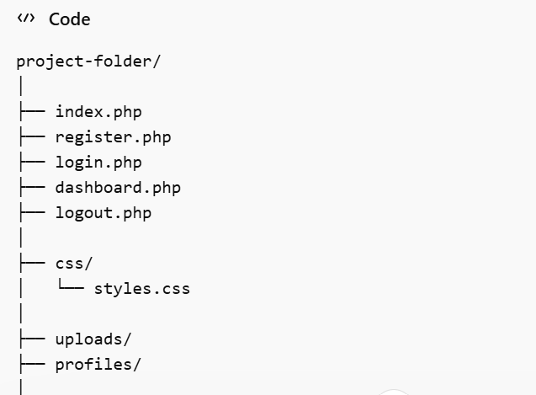

5. Marking Scheme (Total: 30 Marks)
Criteria | Marks
HTML Structure & Semantic Usage | 5
CSS Styling & Layout | 5
PHP Form Handling | 5
Use of Conditional Statements | 5
Session Management (Login/Logout) | 5
File Upload & Basic Validation | 5
Total | 30

6. Submission Requirements ( i will show the students the process)
Students must submit:
- Complete project folder (compressed as ZIP file)
- Screenshots of key pages
- Upload it to GitHub individual in a group.
- Brief report (1 page) explaining:
  - Project title
  - Features implemented
  - Challenges encountered

7. Suggested Project Topics
Students may choose from:
- Student Course Registration System
- Simple E-commerce Website
- Online Food Ordering System
- Blog System
- Event Registration System

